

60-377 Assignment #4 Fall 2013

Artificial Intelligence for Games

School of Computer Science
University of Windsor

Due: Monday, November 14, 2013.

This assignment is about Search Space representation and Pathfinding. as discussed in Chapter 5 and 8 of Mat Buckland’s book. See Chapter 4 in Ian Millington’s book for additional information.
This assignment may be done in groups of 1 to 3.

- Preparation (nothing to hand in)

- Familiarize yourself with the provided framework. There is a Kinematic and a Dynamic version of the motor. These simple versions do not support jumping, sliding, and moving platforms though you are free (but not required) to add these features. I’ve also added Kinematic and Dynamic versions of Seek and Arrive. The Blue Weeble has a Kinematic Motor and uses Kinematic Steering. The Red Weeble has a Dynamic Motor and uses Dynamic Steering. You can enable the Target Selector to experiment with these.
- Explore the two provided Map Generators (Maze ad ConnectedRooms). Note that you can vary the cell sizes or even shutoff map generation so you can use your own map.
- There are two (and a half) Search Space representations provided: Grid (with/without diagonals) and PointsOfVisibility. Try turning on the node and edge displays to see the differences.
- There is a PathManager attached to each weeble. You can manually request a path by checking the PathManager’s Request Path checkbox. Or you can disable the Target Selector and enable the Goal Selector. You can now request paths to the selected objects similar to the way you selected steering targets in Assignment #2.

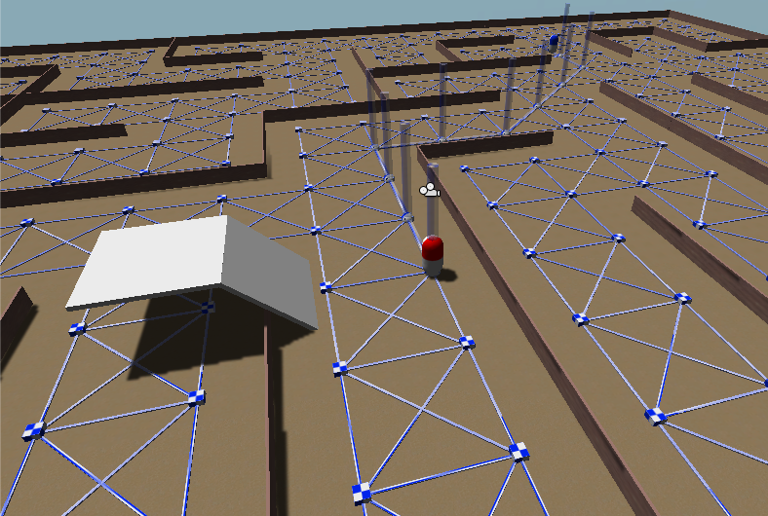

- To do list: Does as many parts as you like. The points indicate the relative value of the parts. The maximum mark is 100 even though the sum of the points is greater than 100.

- [20 points] Required! Document your work. Explain what parts you attempted, how your approach is supposed to work, which parts of the code you modified, removed or added.
- [50 points] Required: Implement and test the Corner Graph search space representations.
- [10 points] Find and correct the bug(s) that occur(s) when switching paths. There are two issues. First, when you are following a path and select a new goal in the Goal Selector, the path is found from the current location but the weeble continues traversing the current edge before switching. You need to provide a way to gracefully switch (cancel traversal of the current edge). Second, if the path is being shown when you switch paths, the initial markers are not correctly cleaned up. This is related to the first part.
- [5 points] Find and correct the bug(s) that occasionally result in a path through a wall!!
- [10 points] Over and under: There is a half-bridge provided. Modify or create at least one search space representation that allows weebles to correctly path over and under the bridge. The bridge is deliberately one way! This may require using a directed graph (which is an option in the underlying sparse graph implementation …).
- [20 points] Currently, each weeble has its own PathManager. Design, implement and test a new path manager (attach it to “Game”). This single path manger should receive path requests from all the weebles. It should queue the requests and process them. It should then send a path request completed (or failed) event to the requestor.
- [5 points] This assumes you did part (10). Now redesign your PathManager to time-slice processing requests (like an operating system does with jobs). To do this, you will need to replace the A* implementation with a time-sliced version (this is easier than it sounds). Basically, each update, you want to do one cycle of A* for each requestor. One cycle means remove the next node, process it, add its children, return.
- [5 points] This assumes you did part (11). Implement Quick Path.
- [5 points] Implement path smoothing.
- [5 points] Detect and deal with situations where the weebles get stuck or take too long to complete an edge or the path.
- [5 points]⁺ Impress me (one or more time: 5 points each).

